Christian Jay M. Putol

05/23/2023

Install Windows Server 2012 R2

In this project, you install Windows Server 2012 R2. You need the installationDVD for either the Windows Server 2012 R2 Standard or Datacenter edition.You can download a 180-day evaluation of Windows Server 2012 R2 fromwww.microsoft.com/en-us/evalcenter/evaluate-windows-server-2012-r2. Youwill be asked to sign in using your Microsoft account, which you can createif you don’t already have one. After you download the ISO file, burn it to aDVD.

The installation procedure for Windows Server 2012 R2 is nearly identicalto that of Windows 10 until the system restarts. Only screens that aresubstantially different are shown in this project. This installation procedureassumes that no other OS is installed on the computer and that

the disk is unpartitioned.

*You can also use Windows Server 2016, if it’s available, for this project. Only*

*the preview was available at the time of this writing, so Windows Server 2012*

*was used.*

*Instructions:*

1. Save as this file to your account.

Locate the ISO disc image file from this directory(E:\Platech Installers). Use your name for your virtual machine.

1. Put your screenshots and answers after each step.

1. Insert the Windows Server 2012 R2 installation DVD in the DVD drive of a computer

that meets the minimum requirements for Windows Server 2012 R2.

2. Start your computer if you are sure it will boot to the DVD.

3. After the Windows logo is displayed, Windows Setup begins. The screen prompts you

to choose your language and location preferences. Click Next.

4. On the next screen, you have the option to repair your computer or install the OS.

Click Install now.

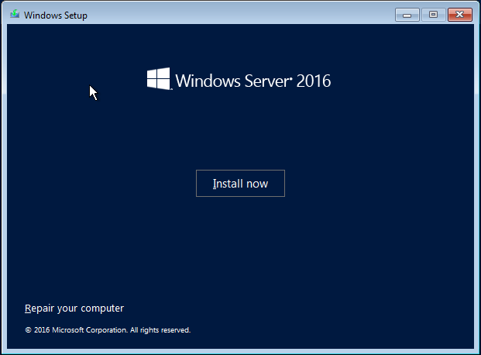

5. You are prompted to choose the operating system to install (see Figure 5-16). Depending

on your installation media, you may be able to choose from Server Core or Server

with a GUI for either Standard edition or Datacenter edition, as shown in Figure 5-16.

The installation is identical for both editions. Choose Server with a GUI and click

Next. If you are using an edition that requires an activation key, enter it on the next

screen: otherwise, read the Windows Server 2012 R2 Licensing terms, click I accept

the license terms and click Next.

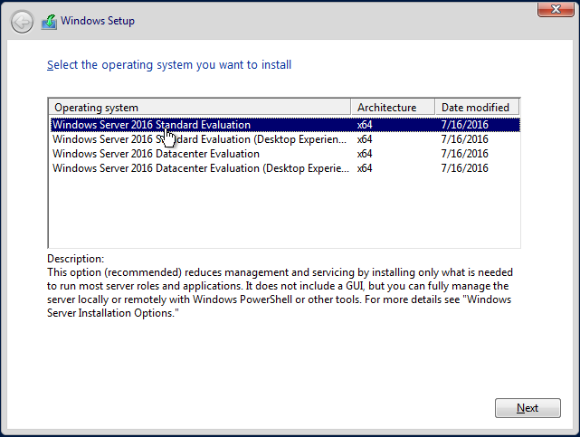

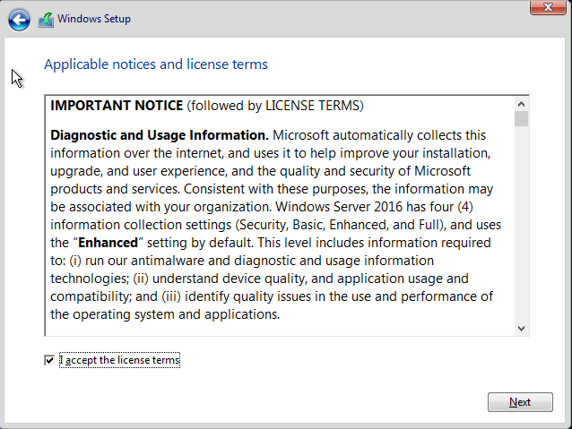

6. The next screen asks, “Which type of installation do you want?” Click Custom to perform

a clean installation.

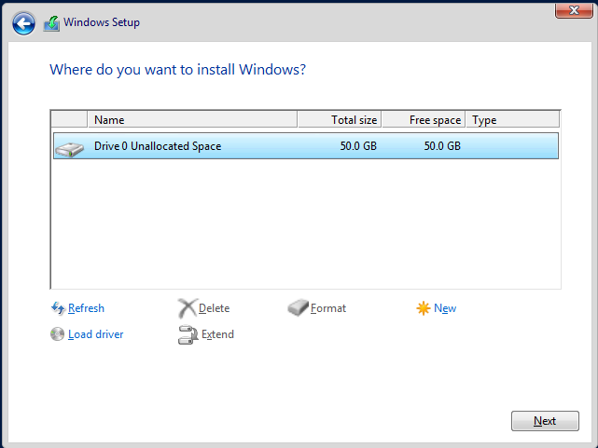

7. Click the disk on which to install Windows Server 2012 R2, and then click Next. The

setup program copies files and installs Windows Server 2012 R2. The computer will

restart at least once. When the computer restarts, be sure to remove the installation

DVD, or the computer might boot to the DVD and start the installation process from

the beginning.

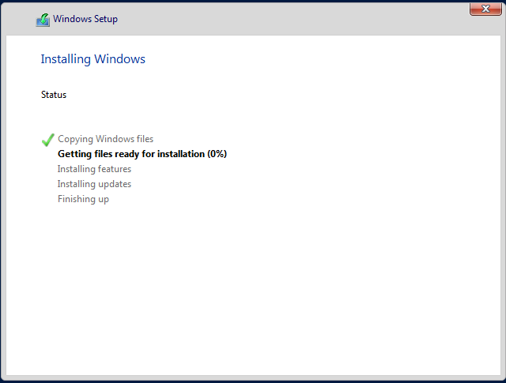

8. After the computer restarts, you are prompted to enter a password for the Administrator

account. You must use a password that meets minimum requirements. Type Password01

in the Password and Reenter Password boxes and click Finish.

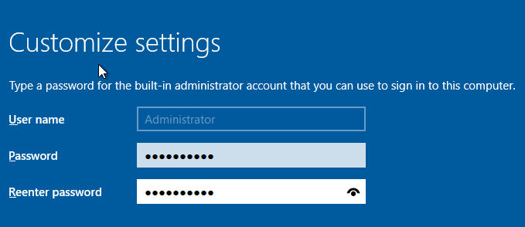

9. To log on to Windows Server 2012 R2, press Ctrl+Alt+Delete, enter the password for

Administrator, and press Enter.

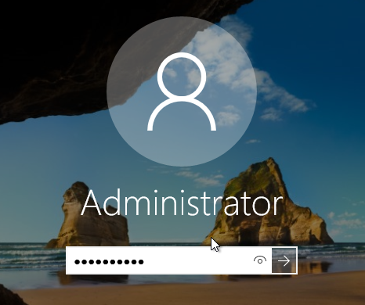

10. If you are connected to a network, you are asked if you want to allow your PC to be

discoverable by other PCs on the network. Click Yes unless you are on a public

network.

11. Windows Server Manager automatically starts and displays the Windows Server 2012

R2 Server Manager Dashboard (see Figure 5-17).

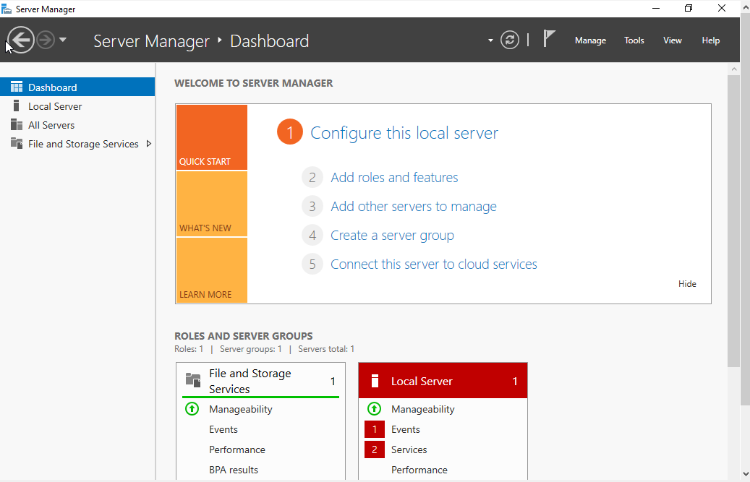

12. Click Local Server in the left pane to see and change basic settings. On this screen (see

Figure 5-18), you can change the computer name, join a workgroup or domain, change

IP address settings, configure Windows Update, and so on.

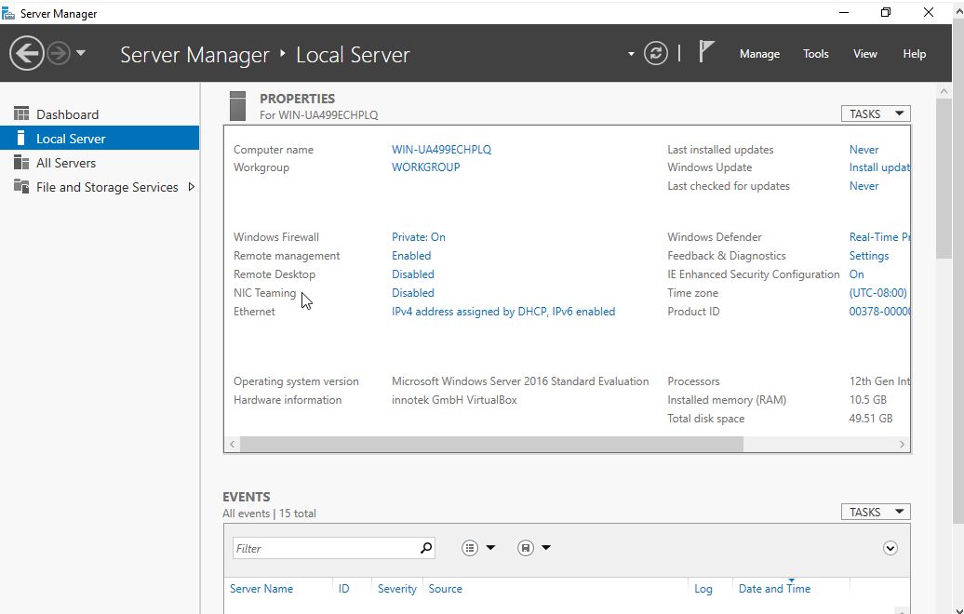

13. Log off or shut down your computer.